**ANESTHESIA INHALATION MACHINE AND METHOD**

Patent application, including specification and drawings,

published on the site [**www.minivap.net**](http://www.minivap.net) **28.04.2017**

Inventors: **Alexander Z. Berlin, Elly B. Berchanskaya, Fima J. Tsipin**

**Int. Cl………………..A61M 16/00,** A61M 16/10, A61M 17/00, A61D 7/04

**US Cl………………...128/188,** 261/47

**Field of Search**………128/203.25, 261/47, 261/104

**References Cited**

U.S. Patent Documents

20,160,279,373 03/2015…………..261/47

20,140,034,050 02/2014…………..128/203.12

RU Patent Document

2,372,947 02/2008………….A61M 16/01

**FIELD OF INVENTION**

This invention relates to anesthesia machines, and more specifically to devices and methods for saturation of a breathing gas with vapors of volatile anesthetic.

**BACKGROUND OF THE INVENTION**

Main problems of inhalation anesthesia include:

1 - The need for sophisticated and bulkyanesthetic equipment (especially compared to what is used for intravenous anesthesia).

2 - Non-stability of the well-known draw-over vaporizers (OMV, Ohmeda PAC, Goldman vaporizers) is associated with unpredictable output and inadaptability to gas flows below 3 L/min **[**Watney G. *In- and Out of Circuit Vaporizers.* Anesthesia Equipment Resources ASE 2007, [www.asevet.com](http://www.asevet.com); Dobson MB. .*Anaesthesia at the District Hospital.* 2nd ed. 2001**]**.

3 - Delayed concentration in closed and semi-closed systems, while the concentration inspired by the patient is not known with certainty in spite of an accurate Vaporizer Out of Circuit (VOC).

For example, at the minimum oxygen flow 250 ml.min-1 the supply of “anesthetic agent reaches its limits…with isoflurane – and that would be more striking with enflurane or halothane – the individual uptake of an adult patient exceeds the amount of agent which maximally can be supplied into the breathing (VOC) system” **[**Baum J*A. Low Flow Anesthesia.* Drager 2004**]**.

The delivered anesthetic vapor flow may be increased by serially connected agent -specific vaporizers kept out of the circuit **[**Otero PE, Rebuelto M, Hallu RE, Aldrete JA. *Increasing Anesthetic Concentration without Modifying FGF by Serial Connection of Vaporizers.* ALFA 2003; 1-7**]**.

In these systems, there is a significant difference between the inspired anesthetic concentration and the corresponding vaporizer setting in VOC circulation systems (Table 1), which is an additional inconvenience for the anesthesiologist.

The lower the fresh gas flow, the higher the concentration to be dialed at the VOC to maintain a desired anesthesia depth.

Table 1

Data of inspired mixture of Sevoflurane (S) or Isoflurane (I) and O2 during mini- and low-flow anesthesia with a vaporizer OUT of the breathing circle **[**Baum J*A. Low Flow Anesthesia.*Drager 2004**]**

|  |  |  |  |  |
| --- | --- | --- | --- | --- |
| Fresh gas flow FO2, L/min | | 0.25 | 0.5 | 1 |
| Vaporizer setting / Inspired concentration, CV/ CI | S | **8/2.8** | **5/2.8** | **3/1.8** |
| I | **5/1.2** | **5/1.8** | **2/1** |

On the other hand, the super-complex anesthesia machine (station) Physio FlexTM with an electronically controlled vaporizer changes sevoflurane concentration from 0 to 2 vol.% in 80 to 510 s **[**Suzuki A., Bito H., Sanjo Y et al. *Evaluation of the PhysioFlexTM Closed-circuit Anaesthesia Machine.* Eur J Anaesthesiol, 2000. **17**, 6, 359-363**]**.

However, these methods and equipment are excessively complex and expensive.

4 - Significant and useless consumption of expensive anesthetics when the anesthesia regimes change; thus, only during the induction and with a double change in the inhaled concentration of isoflurane from 1.5 to 3% in a breathing circuit with a volume of VC = 5 L, approximately 10-12 ml of liquid anesthetic is wasted in atmosphere.

5 - Significant inertia of transients and the formation of poorly ventilated zones in a relatively large respiratory circuit for a small patients with a relatively low minute ventilation, which does not allow optimal control of anesthesia. So, at an oxygen flow rate of FO2 = 60 ml / min for an animal weighing 5 kg a delay of about 1.5 hours (according to Conway`s formula delay, i.e. time T = VC .FO2-1).

These disadvantages make it difficult to use the known advantages of inhalation anesthesia with respect to intravenous (less metabolism and trauma, natural way of administration of anesthetic together with oxygen) and accordingly limit its use.

The mentioned problems may largely (except for item 5) be solved by using stable low resistance vaporizer IN the breathing circuit of anesthesia machine. So, RU Patent No. 2,372,947 describe an anesthesia machine comprising a stable low resistance vaporizer “MINIVAP” located in the reversible breathing circuit with inhalation and exhalation valves, patient tee, reserve bag and absorber of exhaled carbon dioxide.

This simple apparatus due to the inclusion of the vaporizer inside the breathing circuit (VIC) allows much faster adjust the inhaled anesthetic concentration, and, accordingly, the anesthesia depth (within 3-5 minutes).

However, this apparatus also has a noticeable inertia and poorly ventilated zones of the respiratory circuit during the anesthesia of small patients (animals).

**SUMMARY OF THE INVENTION**

According to the present invention, it is provided an anesthesia machine for saturation of a breathing gas with vapors of a volatile anesthetic; said machine comprising a stable low resistance vaporizer located in the a reversible breathing circuit with inhalation and exhalation valves, patient tee, reserve bag and absorber of exhaled carbon dioxide. The reversible circuit equipped with blower of variable output.

Advantageously, said blower is designed as an elastic bag, placed between the patient and his tee.

In the one embodiment, wherein said elastic bag is used as a chamber for small animals.

In a number of cases, taking into account the configuration of the animal's head, said elastic bag used as a mask.

According to the invention, a method of inhalation anesthesia comprises increase the inhaled anesthetic concentration by additional circulation of breathing gas with a blower in the breathing circuit.

In the one modification, maximum concentration of inhaled anesthetic reach with a maximum speed at the highest vaporizer scale mark and the closed safety valve when there are maximum frequency and amplitude squeezes of the elastic bag.

Advantageously, inhaled anesthetic concentration **CI** while anesthesia maintenance is proportional to circulation velocity **FCircl** of breathing gas and inversely proportional to oxygen (or air) flow rate **FO2** according to ratio

**CI ≈ CV FCircl (1 - Cas) / FO2**, where **CV** - vaporizer scale mark, **Cas** - saturated vapor concentration of anesthetic.

Advantageously, cleaning of the breathing circuit from the anesthetic vapors is performed by periodically squeezing the elastic bag with the simultaneous supply of oxygen or atmospheric air into the circuit, open the safety valve and vaporizer at zero scale.

The anesthesia inhalation machine and the method provides adequate anesthesia of small animals up to 5 kg (rodents, birds, cats and dogs, reptiles and amphibians) practically in any conditions: in the hospital, emergency situations and ambulance.

So, significantly increases up to several times the inhaled anesthetic concentration and the rate of change in the anesthesia depth during surgical operations.

At the same time, reduces consumption of anesthetics, as well as medical gases, pollution of the operating environment by reducing emission of anesthetic vapors, including halogen-containing.

**BRIEF DISCRIPTION OF THE DRAWINGS**

In order to understand the invention and to see how it may be carried out in practice, a preferred embodiment will now be described, by way of non-limiting example only, with reference to the accompanying drawings, in which:

**Fig. 1** is a principal scheme of an anesthesia inhalation machine.

**Fig. 2** is the anesthesia machine containing a flowmeter and Ambu bag 1200 ml with hedgehog and mouse.

**Fig. 3** is the anesthesia machine containing a second Ambu bag 300 ml for air supply.

**Fig. 4** is the anesthesia machine containing an absorber (vertical translucent Ambu bag 300 ml).

**Fig. 5** is Isoflurane concentration at the outlet of the stable low resistance vaporizer “MINIVAP-20/I” depending on the oxygen flow.

**Fig. 6** is Isoflurane inspire concentration of the anesthesia machine depending on the ratio FO2 / MV (CV = 5 vol%; MV = FCircle = ΔV x f = 0.2 x 30 = 6 L / min, where ΔV - volume change Ambu bag, L; f –its frequency, min-1, the circle volume about 1 liter).

**DETAILED DISCRIPTION OF THE INVENTION**

A principal **scheme** of an anesthesia machine for inhalation anesthesia is shown in **Fig. 1**. The anesthesia machine comprising a stable low resistance vaporizer **1** located in the a reversible breathing circuit **5** with inhalation **7** and exhalation **8** valves, patient tee **10**, reserve bag **12**, absorber **15** of exhaled carbon dioxide and pressure relief valve **18**. An oxygen flowmeter **20** or a second Ambu bag **22** for supplying atmospheric air through a unidirectional valve **25** is connected to the breathing circuit **5**.The anesthesia machine is equipped with a gas blower with variable-volume internal cavity in the form of an elastic bag **30** type Ambu, connected through a 22 mm hole **32** with the tee **10** and through the opposite hole **33**, located on its lid **35**, with patient (by means of a mask or an intubation tube, not shown).

In the anesthesia machine modification on **Fig. 2** the said elastic bag **30** at the same time is used as a chamber (volume 300, 600 or 1200 ml) for small animals (there are hedgehog and mouse in the translucent bag 1200 ml). In this case, the patient is placed in the elastic bag **30** through the hole **37** (diameter 32, 50 or 65 mm in different bags) from under the removable lid **35** and its hole **33** is closed with a stopper **40**.

In another embodiment of the present invention, taking into account the configuration of the animal's head, said silicone elastic bag **30** is used as a mask without a removable lid **35,** and through the hole **37** is attached to the patient's head (**Fig. 1, 3, 4**).

The vaporizer "MINIVAP-20/I" is used as a stable low resistance vaporizer **1**, since the anesthetic concentration at its outlet is practically independent of the **oxygen** consumption (**Fig. 5**, see website [**www.minivap.net**](http://www.minivap.net)).

In case of short-term operations and a non-hermetic connection of the patient to the mask, when the suction of atmospheric air is more than the patient's metabolic requirement for oxygen, the absorber**15** can be excluded from the breathing circuit **5** (**Fig. 2, 3**).

Anesthesia machine **operates** in the following way. Depending on the nature of the operation, the patient's parameters and operating equipment (hospital with compressed oxygen, dispensary or field conditions), the optimal model of the anesthesia machine is selected referring to **Fig. 1- 4**.

**Anesthesia Induction.** After the standard preparation and testing of the anesthesia machine, the reserve bag **12** is filled with air or oxygen using the Ambu bag **22** or a flowmeter **20**, respectively. Then, the patient is connected to the breathing circuit **5** through a special mask (not shown) or directly to the elastic bag **30**.

To achieve the **maximum concentration** of inhaled anesthetic is necessary vaporizer **1** scale mark at a maximum, close the pressure relief valve**18**, and with a maximum frequency and amplitude squeeze the bag **30**, attached to the patient (a little patient can be placed inside the bag **30** through a removable cover **35**).

The rate changing of the inhaled anesthetic concentration **ΔCI /Δt** depends on the concentration gradient in the vaporizer **1**, the circuit **5** volume **VCircle**, the rates of gas circulation **FCircle** and the oxygen (air) supply **FO2** and is determined from the relationship (at the initial time) and **Fig. 6**

**ΔCI /Δt = [CV /(1- CV ) VCircle]{[(Cas- CV )(1- Cas) FCircl/(1- CV )Cas]- FO2 } ( I )**

Where **CV** - vaporizer scale mark, **Cas** - saturated vapor concentration of anesthetic.

Here, the gas circulating **FCircl** through the vaporizer can be estimated by squeeze frequency and amplitude of the elastic bag **30**.

**Example I**. If the bag **30** (volume of 300 ml) to squeeze at a frequency of 10 cycles min, the gas circulation through the vaporizer **1** about 2 l/min (0,2L x10 min-1), whereas the inspire concentration **CI** reach **10 vol.%** in the circle (volume 1 liter) at scale mark **CV**= 6 vol.%, air flow 0.5 l / min with a second Ambu bag **22** (**Fig. 1, 3**) or O2 flow throw flowmeter **20,** according to equation **(I)** and **Fig. 6** (ratio **FO2 / MV** = 0,25).

After reaching the required anesthesia depth (duration of the isoflurane induction is about3 min, for sevoflurane – 1,5 min), the patient is intubated if necessary, after which, as a rule, spontaneous respiration is restored.

**Anesthesia Maintenance.** To **reduce inspire anesthetic concentration** necessary to reduce the vaporizer scale and a gas circulation.

**Example II**. At scale mark «1» inspire concentration in the previous example is about 2 vol. %. If reduced circulation rate up to 5 cycles/min (1 l/min), the inspire concentration further decrease up 1,3 vol.%.

On the small and middle scale marks **CV**, when the relative oxygen (air) supply

**FO2 / FCircle** ≥ 0.5, the inhaled concentration is proportional to minute ventilation (circulation) and inversely proportional to oxygen (or air) flow rate **FO2**

**CI ≈ CV MV (1 - Cas) / FO2, (II)**

Where **MV = FCircle**.

To **stop the anesthetic supply**, vaporizer scale should be set to zero, completely open the safety valve and blowing breathing circuit apparatus, at least 10 times to squeeze both the Ambu bags simultaneously.

This easy handling at the same time **prevent patient hypoxia and hypercapnia!**

**Example III**. Weight of the patient 1 kg (metabolic consumption about 4 ml / min O2), breathing circuit volume 1 L. Then 10 simultaneous squeeze’s of two Ambu bags 300 ml will provide triple rinse of the circuit (blowing into the circuit 10 x 0.3 = 3 L of air with its simultaneous circulation). In this circuit the O2 concentration is not less than 15 vol.% (PaO2 = 114 mm Hg) and CO2 - not more than 5 vol.% (PaCO2 = 38 mm Hg), compare Table 16, p. 81. **Veterinary anesthesiology. Nechayev AY et al. 2010**.

The present invention provides adequate anesthesia of small animals up to 5 kg (rodents, birds, cats and dogs, reptiles and amphibians) in any conditions: in stationary surgery, emergency situations and ambulance. The anesthesia machine and method, realized according to the proposed description:

- increases (in **3** times) the anesthetic concentration range of regulation and the rate of change of the anesthesia depth during surgical operation;

- reduce up to several timesthe consumption of anesthetics, as well as medical gases;

- reduces the pollution of the operating environment by reducing the anesthesia vapor emission;

- are universal in anesthetics (**isoflurane, sevoflurane and halothane**) and gases (**oxygen and air**).

The offered models of anesthesia machinesprominent in aportability (weight about **1 kg** instead of **15** at analogues), and their arrangement on a horizontal support allows using it as an operating table for small animals.

Although a description of specific embodiments has been presented, it is contemplated that various changes could be made without deviating from the scope of the present invention. For example, the gas blower of the present invention could be made in the form of a volumetric pump of another type (adjustable membrane, bellows, tubular, drum, etc. internal cavities).

**CLAIMS:**

**1.** An anesthesia machine for saturation of a breathing gas with vapors of a volatile anesthetic; said machine comprising a stable low resistance vaporizer located in the a reversible breathing circuit with inhalation and exhalation valves, patient tee, reserve bag and absorber of exhaled carbon dioxide; wherein reversible circuit equipped with a blower of variable output.

**2.** An anesthesia machine according to Claim 1, wherein said blower is designed as an elastic bag, connected to the patient tee.

**3.** An anesthesia machine according to Claim 1, 2, wherein said elastic bag is used as a chamber for small animals.

**4.** An anesthesia machine according to Claim 1, 2, wherein said elastic bag is used as a mask.

**5.** A method of inhalation anesthesia comprises anesthetic vapor feeding of anesthesia machine reversible breathing circuit due to patient's minute ventilation through a stable low resistance vaporizer, located in the circuit, oxygen flow in the circuit, absorption of the exhaled carbon dioxide with absorber and drain of excessive gas mixture through safety valve; wherein increase the inhaled anesthetic concentration by additional circulation of breathing gas in the circuit using a gas blower, which is installed inside the breathing circuit.

**6.** A method according to Claim 5, wherein the gas blower with variable-volume internal cavity in the form of an elastic bag placed between the patient and his tee.

**7.** A method according to Claim 5, wherein maximum concentration of inhaled anesthetic reach at the highest vaporizer scale mark and the closed safety valve when the maximum frequency and amplitude of squeezes of the elastic bag.

**8.** A method according to Claim 5, wherein a patient is placed in the elastic bag.

**9.** A method according to Claim 5, wherein inhaled anesthetic concentration **CI** at anesthesia maintenance is proportional to circulation velocity **FCircl** of breathing gas and inversely proportional to oxygen (or air) flow rate **FO2** according to ratio

**CI ≈ CV FCircl (1 - Cas) / FO2**, where **CV** - vaporizer scale mark, **Cas** - saturated vapor concentration of anesthetic.

**10.** A method according to Claim 5, 6, wherein cleaning of the breathing circuit from the anesthetic vapors is performed by periodically squeezing the elastic bag with the simultaneous supply of oxygen or atmospheric air into the respiratory circuit, open the safety valve and vaporizer at zero scale.

**ABSTRACT**

An anesthesia machine for saturation of a breathing gas with vapors of a volatile anesthetic; said machine comprising a stable low resistance vaporizer located in the a reversible breathing circuit with inhalation and exhalation valves, patient tee, reserve bag and absorber of exhaled carbon dioxide; wherein reversible circuit equipped with a blower of variable output.

A method of inhalation anesthesia providing increase the inhaled anesthetic concentration by additional circulation of breathing gas in the circuit using a gas blower located in the breathing circuit.

10 Claims, 5 Drawings

ANESTHESIA INHALATION

MACHINE AND METHOD

15

1

5

7 18

10 8

32 25

30 12 20 22

37 35

33 (40) О2 Air

Patient

**Fig.** **1**

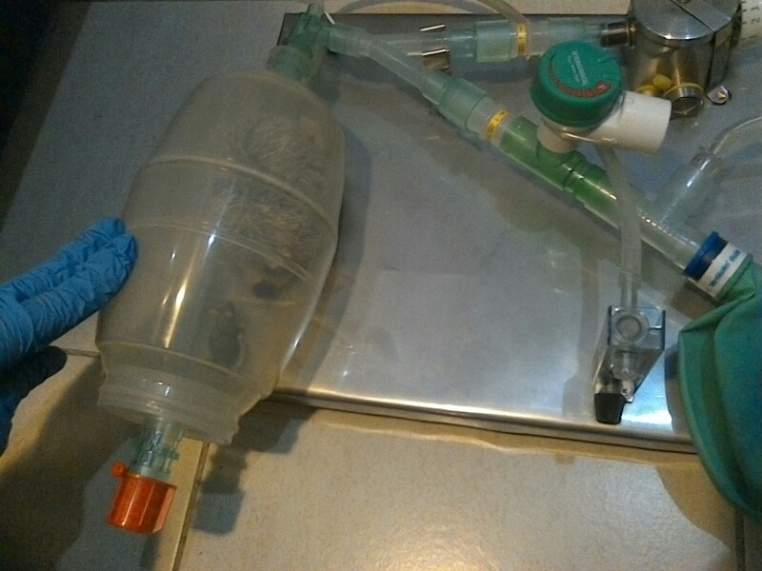

Hedgehog

Mouse

**Fig. 2**

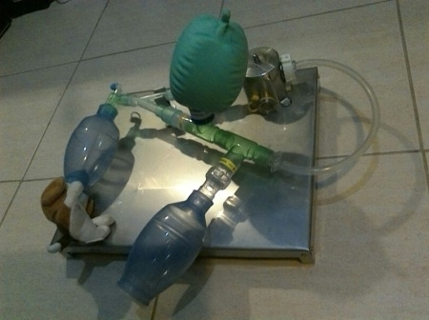

**Fig. 3**

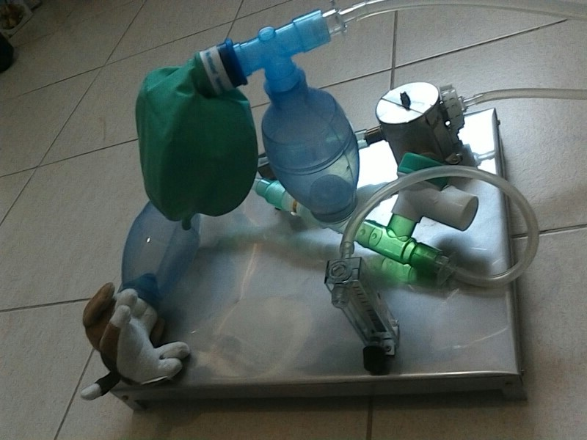

**Fig. 4**



**Fig. 5**

**Fig. 6**

**Air**

**О2**

Пациент