Testing and manufacturing of inhalation Anesthesia Machines (AM) "Colibri" in Israel
1. The situation on the AM "Colibri"
Now manufactured in Russia 6 models of AM "Colibri" on the basis of a small "pocket" (<0.5 kg) and large (1.5 kg) vaporizers “MINIVAP” (Prospectus).

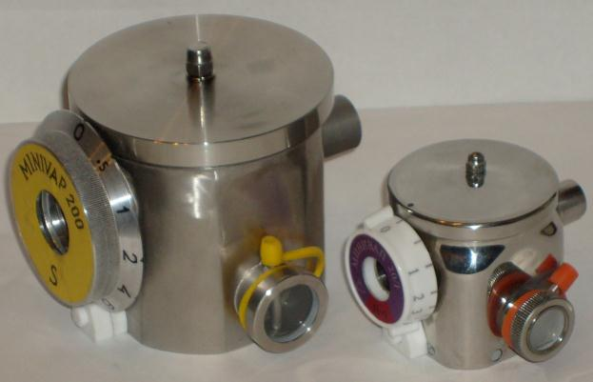
Fig. 1. Vaporizers "MINIVAP-20/I» (to the right) and "MINIVAP-200/S»
from stainless steel or titanium (MRI)
At the end of 2016 we developed 2 more models with Vaporizer In the breathing Circuit (VIC), allowing you to double the maximum inspire anesthetic concentration (prepared materials for the invention "Method and apparatus inhalation anesthesia", which can be issued in Israel and / or Russia).
Price of AM "Colibri" is from $ 1000 to 1500 depending on the configuration; the same price of Chinese analogues with obsolete vaporizers for veterinary medicine.
There are Russian certificates.
Now about 100 AM "Colibri" are working in hospitals and clinics (pediatric surgery and dentistry - see video film on www.minivap.net), as well as in veterinary medicine of Russia and Ukraine (surgery from mice to horses).
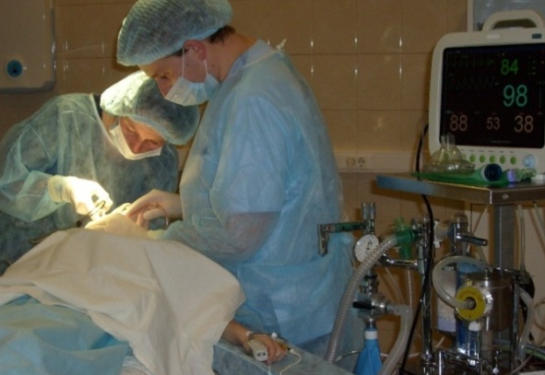  Fig. 2. Vaporizer «MINIVAP-200/S» OUT of circuit MK-110, Japan (maxillofacial surgery) | 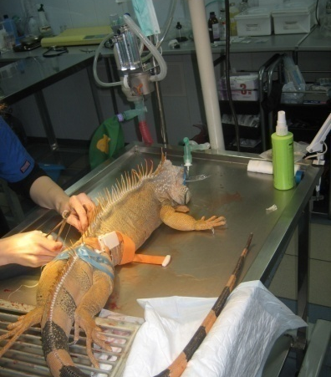  Fig. 3. Anesthesia Machine «Colibri» on the stand for transfusion

In the autumn of 2016 in Israel began to work the 1st AM "Colibri" in a veterinary clinic Nahariya (see the letter - review).

2. Market of Anesthesia Equipment
There are about 5 million/year general anesthesia in Russia, 1/3 of them is inhalation. In Germany and England - about 10 million common anesthesia, 60% - inhalation.
Annual global sales of anesthetics, $: Sevoflurane - 1 mrad, isoflurane - 100 million, one-third of them - veterinary medicine. If we take 20 ml of sevoflurane on the hour-long operation (more than 50% of the total), it goes up to 50 million / year sevoflurane inhalation anesthesia only.
There is world production of Vaporizers about 100 thousand / year (about $ 200 million), Anesthesia Machines - about $ 2 billion. The Russian market of anesthesia and respiratory equipment is about 2% of the world.

3. Manufacturing and Components of AM "Colibri"
AM “Colibry” consist of low resistance vaporizer (manufactured aircraft factory) and elements of the breathing circuit (from Europe and US).
The simplest model for emergency anesthesia includes "pocket" vaporizer, Ambu bag for resuscitation, non-reversible valve and face mask (unit mass less than 1 kg) - show the work.
It's only our new vaporizers are produced in Russia (firm MITK-M and Aviation Plant "Air-repair" are manufacturers , the firm "MINIVAP" is developer and actually assembles and verifies these machines and vaporizers).
Russian firm "MINIVAP" works 10 years and is the successor of the Israel venture firm «Laminar Technology Ltd» (2001-2006, see business card).
Over the years, carried out the necessary technical and clinical tests in the veterinary, adult and children's clinics, there are Russian certificates for medical use in clinical practice, production and sales.
AM “Colibri and methods for their medical applications are protected by dozens of patents in Russia, Israel and the United States (see 2 Russian and 1 Israel).

4. Features of vaporizers and AM “Colibri”
The AM consists of the “MINIVAP” vaporizer ("pocket" or stationary, are made by Russian aviation plant) and the breathing circuit elements (tubing, bags, face-masks and valves from Europe).
The devices 5-10 times less analogs and surpass their main parameters: efficiency (2 times higher anesthetic concentration range and adjustment speed), low breathing resistance, anesthetic saving (price $ 1 / ml) and the cost of production. Due to low resistance AM “Colibri” are compatible with any breathing apparatus and oxygen concentrators and can work without oxygen cylinders.
The “MINIVAP” vaporizers ("pocket" 300 g and stationary 1.5 kg, from stainless steel or Titanium) are suitable for any patients (adults and children as well as animals, from mice to horses) in hospitals and emergency situations (ambulance and military field conditions).
The vaporizers are biotech: the evaporation chamber works like the gills of fish (its elements are equipped with a stainless mesh with a cell of 30 microns – Fig. 4A), and the concentration control valves, as well as our breathing system, consist of well streamlined low-resistance elements (including automatic thermo- and bar-compensator with the mini-bellow – Fig. 4 B).

5. Testing, patenting and manufacturing of AM “Colibri” in Israel:
5.1. Approbation and sale of the devices for veterinary medicine.
5.2. Exposition of the devices in Israel and Dusseldorf (“MEDICA”).
5.3. Company organization, patenting and licensing.
5.4. Production in Israel:
- The purchase of "pocket" vaporizers (400 g stainless steel, 300 g of titanium for MRI) from Russia;
- Purchase of the breathing circuit components from Europe;
- Assembly and testing AM “Colibri” in Israel.
There is production cost about $ 500, the planned price about $ 1500-2000.
5.5. After the sale of the first 50 devices suitable their certification in Europe (it costs about $ 50 thousand) for sales in Europe, Asia, Africa and South America.

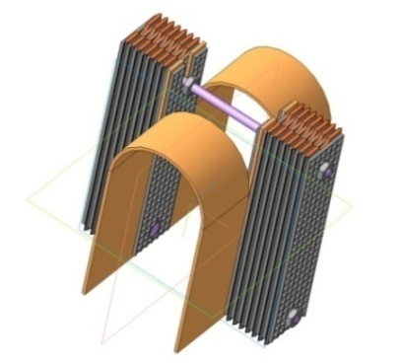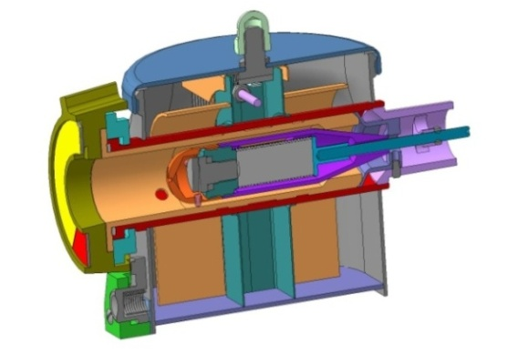
A – Evaporation elements B - thermo- and bar-compensator with the
mini-bellow

Fig. 4. Vaporizers "MINIVAP-20/I»

The devices are extremely necessary in emergency situations (military field conditions, natural and man-made disasters). To do this, it can be additionally equipped with a mini oxygen concentrator (US Airsep Focus) and mini ventilator (US SAVe ™ VENTILATOR - Simplified Automated Ventilator for Special Force medics). Thus, it turns out the world's smallest and lightest portable Anesthesia Kit (Fig. 5).
This kit can be supplemented with the separation chamber («bag in vessel», RU patent No
2466749) for modern low-flow anesthesia in district hospitals and remote regions.

Airsep Focus О₂ concentrator (0,8 kg)  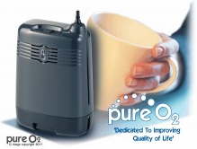 | Vaporizer MINIVAP-20/I (400 g)
Mini ventilator SAVe™ ( 1,8 кг)
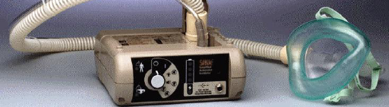
Fig. 5. Portable kit for inhalation anesthesia and artificial respiration

References
- Sidorov V.A., Tsipin L.E., Grebennikov V.A. Pediatric Inhalation Anesthesia. Moscow 2010 - 184 p.
2. RU Patents № 2329069, 2372947, 2383362, 2490034, 2497553, Patent Application Israel No 166242 11.01.2005.
3. Berlin A.Z., Meshcheryakov A.V. Inhalation anesthesia and vaporizers. M., 1980 - 112 p.

Director of Scientific & Manufacture Manager of Production Development
Venture Firm “MINIVAP” Ltd AM “Colibri” in Karney Shomron
___________ Alexander Berlin _____________ Shlomo Zvi Chak
+499 907 2872 Moscow +052 6374 304 Nave Menachem
Otradnaya str. 1/76
09-7929079, 054 399 6747 Manager of logistics and advertising
Nave Menachem _____________Fima J. Tsipin
aleberlin@mail.ru +054 7802 786 Nave Menachem
www.minivap.net
Manager of Connexions and Sales
_____________Uri Magal
+054 5873 893 Nave Menachem

Chief technologist
_____________Baruch Rashkovan
+0544 737 524 Nave Menachem

March 2017

